
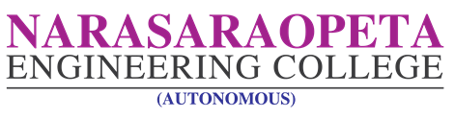
Kotappakonda Road, Yellamanda (Post), Narasaraopet – 522601, Guntur District, A.P., India.
Approved by AICTE, New Delhi & Permanently affiliated to JNTUK, Kakinada, Code: 47,
Accredited by NBA & NAAC, ISO 9001: 2015 Certified Institution
Phone: 08647-239905 Website: www.nrtec.in

Date: 04/05/2026

The following Placement Committee has been reconstituted for the academic year 2025-2026.

S.NO | NAME | DESIGNATION | DEPT | Position
1 | Dr.S.Venkateswarlu | Principal | ECE | Chairman
2 | D.Umasankar | TPO | TPC | Convener
3 | M.Suresh | Asst. Professor | CSE | Member
4 | G.D.Sundara Rao | Asst. Professor | ECE | Member
5 | G. Naga Raju | Asst. Professor | EEE | Member
6 | K.Kiranchand | Asst. Professor | MECH | Member
7 | K.Anil Kumar | Asst. Professor | CIVIL | Member
8 | T.Manoahr | Assoc.Professor | IT | Member
9 | N.Siva Ramakrishna | Asst.Professor | CSE(ET) | Member
10 | G.Sai Krishna | Asst. Professor | MCA | Member
11 | G.Anil Kumar | Assoc. Professor | MBA | Member

