Vision
To be a center of excellence with state of art infrastructure and imbibe knowledge on advanced technologies in the field of Civil engineering with a focus on research and sustainable development for the benefit of society.
Mission
- Train the students as technologically motivated Civil engineers and researchers who can serve the society competently, collaboratively and ethically as planners, designers, constructors and operators.
- To provide quality based consultancy services to the communities for the development of civil engineering industry and other allied fields.
- To ignite innovative thinking, entrepreneur skills among students
New Trends in Technology:
LIGHTING-EMITTING CEMENT
Lighting-emitting cement is a new type of concrete that glows in the dark without electricity by absorbing light during the day and releasing it at night. This is achieved by modifying the cement's microstructure to allow light to penetrate and by adding phosphorescent additives or optical fibers. It has potential applications in roads, sidewalks, and decorative architectural elements, offering an energy-efficient and durable lighting solution.
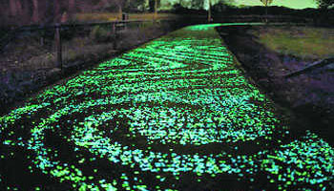
STRAND RODS:
Strand rods are manufactured using carbon fibre composites in both synthetic and inorganic fibres and thermoplastic resin. It has been developed and tested in Japan to create a lightweight seismic reinforcement system. It is much lighter than metal rods of the same length and strength while being equally effective. As the lightest seismic reinforcement, it has high tensile strength and is also aesthetically pleasing. The first use of such material can be seen in the facade of Kengo Kuma’s work for Komatsu Seiren’s head office.
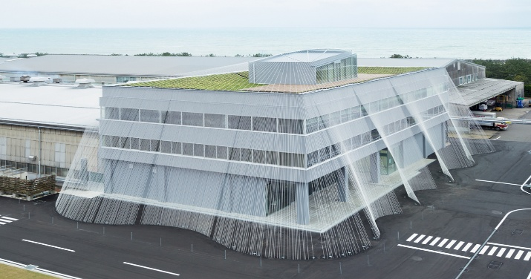
Faculty Focus
- Dr.P.Naga Sowjanya delivered Lecture on “Applications of Remote Sensing and GIS in civil Engineering “in Two -Day Workshop on Real Time Applications in Civil Engineering organized by ST. Ann’s College of Engineering & Technology(A), Chirala on 11-12 August,2025.
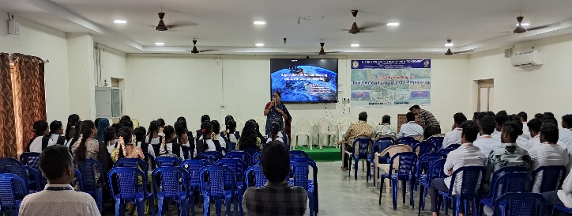
- Dr.P.Naga Sowjanya published book chapter titled as “Integrating Static and Dynamic Risk Management for Enhanced Tunnel Construction Safety” in Recent Trends and Advances in Construction, Real Estate, Infrastructure and Project Management (CRIP) Sector (pp.226-235) in Oct-2025.
- Dr.P.Naga Sowjanya completed NPTEL Course in Sustainable Engineering concepts and Life Cycle Analysis with Elite status during July-September 2025.
- Dr.P.Naga Sowjanya completed NPTEL Course in Geographical information system with Elite status during July-September 2025.
- Dr.P.Naga Sowjanya completed NPTEL Course in Wastewater Treatment and Recycling with Elite status during July-October 2025.
- Mr.K.Anil completed NPTEL Course in Research Methodology during July-September 2025.
- Mrs. A.Lakshmi Prasanna completed NPTEL Course in Sustainable Engineering concepts and Life Cycle Analysis with Elite+Silver status during July-September 2025.
- Mrs. A.Lakshmi Prasanna completed NPTEL Course in Wastewater Treatment and Recycling with Elite status during July-October 2025.
- Mr.M.N.S.Sambasiva Rao completed NPTEL Course in Urban Utilities Planning: Water supply, Sanitation and Drainage with Elite+Silver status during July-September 2025.
- Mr.B.V.Sinivasa Rao completed NPTEL Course in Building Materials and Composites during July-September 2025.
Conferences/ Webinars/ Seminars/ Workshops/FDP s attended:
- Dr.P.Naga Sowjanya attended Five days FDP on “Innovations in wastewater treatment: Harnessing Natural adsorbents for Sustainable Solutions” from November 10-14,2025 organized by MITS, Madanapalle.
- Mr.M.N.S.Sambasiva Rao attended Five days FDP on “Innovations in wastewater treatment: Harnessing Natural adsorbents for Sustainable Solutions” from November 10-14,2025 organized by MITS, Madanapalle.
- Mrs.A.Lakshmi Prasanna attended Five days FDP on “Innovations in wastewater treatment: Harnessing Natural adsorbents for Sustainable Solutions” from November 10-14,2025 organized by MITS, Madanapalle.
- Mr.Sk.Sydha attended Five days FDP on “Innovations in wastewater treatment: Harnessing Natural adsorbents for Sustainable Solutions” from November 10-14,2025 organized by MITS, Madanapalle.
- Mr.B.V.Srinivasa Rao attended Five days FDP on “Innovations in wastewater treatment: Harnessing Natural adsorbents for Sustainable Solutions” from November 10-14,2025 organized by MITS, Madanapalle
Student focus
- Mrs.B.N.V.Jyothi,PG Scholar has successfully participated &completed ATAL FDP on “Disaster Management and Resilient Infrastructure (Strategies, Technologies and Innovations) at Chalapathi Institute of Technology from 10/11/2025 to 15/11/2025.
Important Activities held in the Department
- Civil Engineering Department organized the Engineers Day event on the occasion of Sir M.Viseswarayya garu on his birth Anniversary on 15-9-2025.
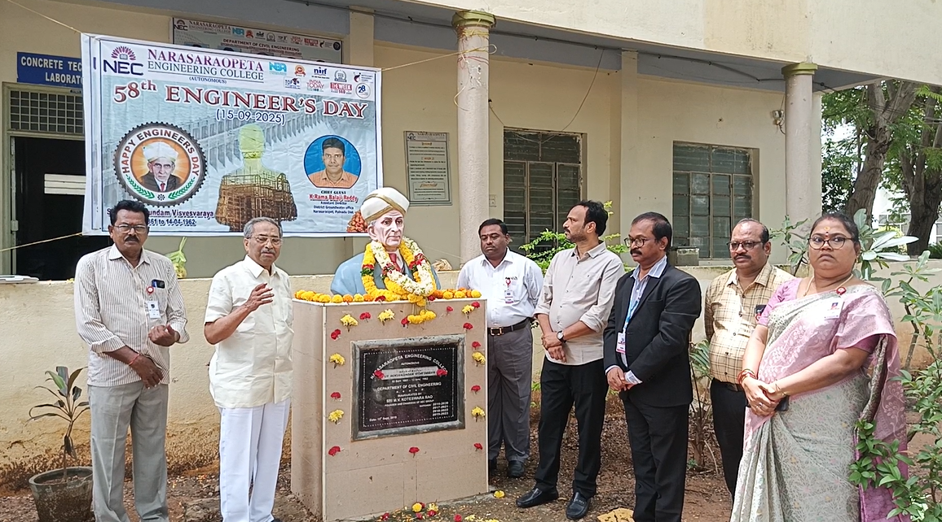
- In collaboration with CPLR, Chennai, the Civil Engineering Department of Narasaraopeta Engineering College, Narasaraopet organizing a two-week workshop on “REVIT & PRIMAVERA” from 8th September to 20th September,2025.
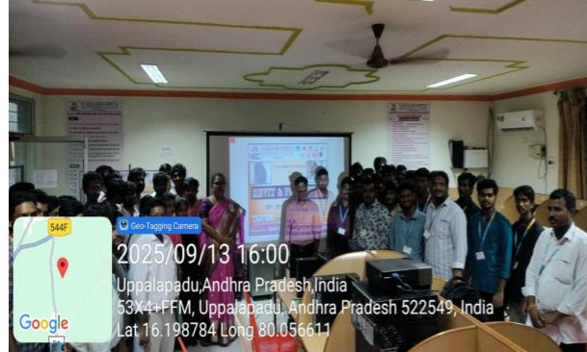
Alumni talk
- Ajay Kumar.G (19471A0103), Assistant Site Engineer, JoshithaInfratech Pvt. Limited, Hyderabad. shared his work experience to II-, II- & IV-year students on 12 August,2025.
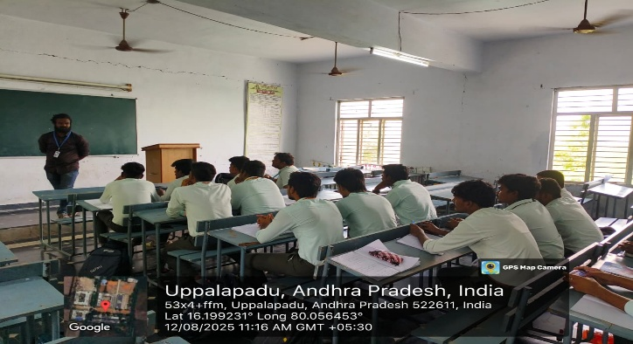

Academic toppers
- III, II B. Tech students who stood top in their Academic Semester exams.
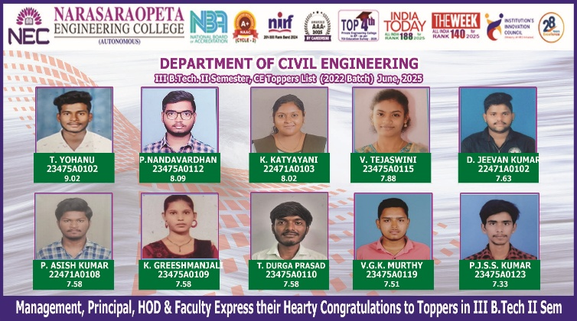

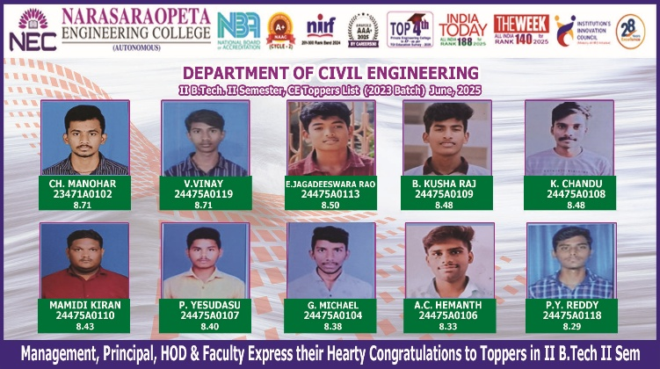

Alumni Voice
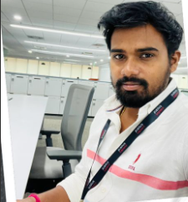
I feel fortunate to be a student of Narasaraopeta Engineering College as it helped me to both on personal and professional front. It inculcated a lot of intra and interpersonal skills which helped me in all round development. Teaching by the senior faculty and the field exposure in my college life has helped me a lot in securing a good job. Personal care towards me by the faculty members has helped me in qualifying the competitive exams at national level. I thank the management of the college for providing necessary materials and books in the library to face the competitive world.
S.Murali,Regd No.12471A0102, Data Technician, Publicis Global Delivery,Hyderabad.
Student’s Voice
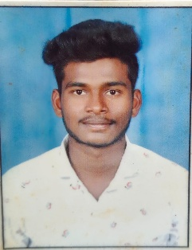
I acknowledge that my knowledge has been enriched due to my association with our department. Knowledge transformation programs (Guest lecture, workshops, Industrial Visits & skill development programme) conducted to the students is really helpful to face global competition.
T.Yohanu, Regd. No.23475A0102, IV B. Tech

