–

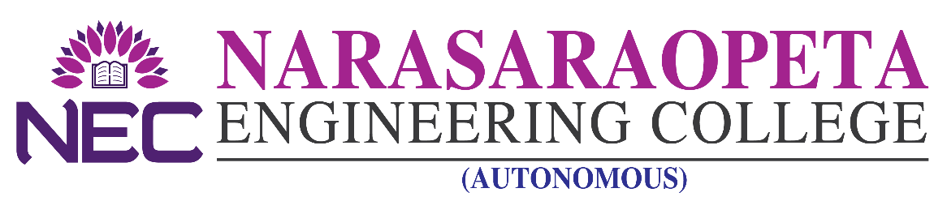
–––––––––––––––––––––––––––––––––––––– ––––––––––––––––––––––––––– ADMISSION DETAILS

NEC offers the following B. Tech courses under Category B quota.

Applications are invited for admission into Category B Seats for the academic year 2023-24 from eligible candidates as per G.O issued by the Govt. of A.P. with respect to admissions in unaided non-minority self-financing colleges. Application can be downloaded from the college Web Site www.nrtec.in The filled in application can be submitted in person/ by post/by email to admissions@nrtec.in so as to reach the college Administrative Office on or before 26.08.2023, 4.00 PM. Admissions will be based as per the Guide lines issued by APSCHE.

DETAILS OF UNDER-GRADUATE COURSES

Courses Offered | B.TECH
 | CSE | ECE | EEE | ME | Civil | IT | CSE(AI) | CSE  (AI&ML) | CSE  (DS) | CSE  (CS) | AI&ML
Intake | 420 | 360 | 60 | 60 | 60 | 120 | 120 | 60 | 60 | 60 | 60
Seats under NRI- Category | 126 | 108 | 18 | 18 | 18 | 36 | 36 | 36 | 18 | 18 | 18
Tuition Fee | As per Govt. Order

PRINCIPAL

