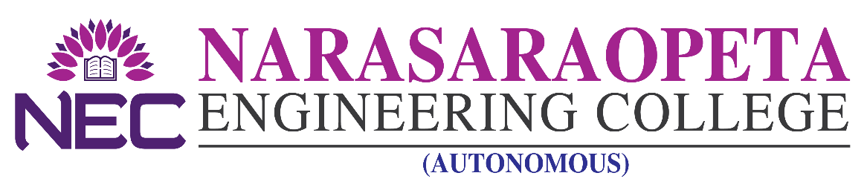

Kotappakonda Road, Yellamanda P.O. Narasaraopet-522 601, Guntur Dist (A.P) (Approved by AICTE & Permanently Affiliated to JNTUK, Kakinada)
Accredited by NBA & NAAC with ‘A’ Grade
Ph. 08647-239907, 8106306313, 9059064616

Admissions under Category-B: NRI/NRI SPONSORED Seats in B. Tech – 2021-2022

SCHEDULE OF ADMISSIONS:

- Date of Issue of Notification : 08.09.2021
- Last Date for Sale and Submission of Application : 15.09.2021
- Last date of receiving applications : 15.09.2021
- Date of Publishing of Selection list : 16.09.2021

PRINCIPAL

