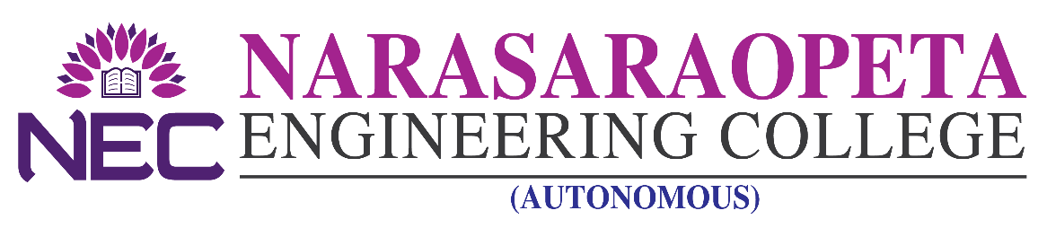
–––––––––––––––––––––––––––––––––––––– ––––––––––––––––––––––––––– ADMISSION DETAILS

NEC offers the following B. Tech courses: NRI/NRI SPONSORED as per the details given below.

Applications are invited for admission into B - Category Seats for the academic year 2021-22 from eligible candidates as per G.Os issued by the Govt. of A.P. from time to time in respect of admissions in unaided non-minority self-financing colleges. Application can be downloaded from the college Web Site www.nrtec.in The filled in application can be submitted in person/ by post/by email to admissions@nrtec.in as to reach the college Administrative Office on any working day on or before 4.00 PM of 15.09.2021. Admissions will be based as per the Guide lines issued by APSCHE.

UNDER-GRADUATION

Courses Offered | B.TECH
 | CSE | ECE | EEE | ME | Civil | IT | CSE(AI)
Intake | 240 | 240 | 120 | 120 | 120 | 60 | 60
Seats under B - Category | 72 | 72 | 36 | 36 | 36 | 18 | 18
Tuition Fee | As per Govt. Order

PRINCIPAL

