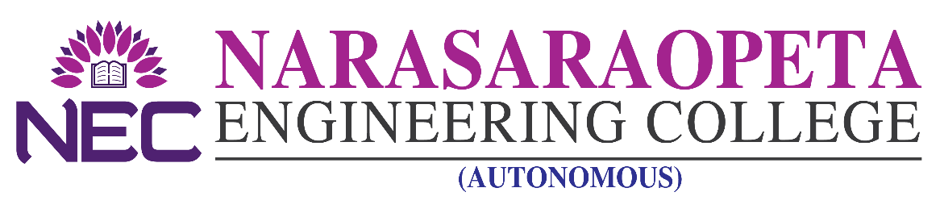
–––––––––––––––––––––––––––––––––––––– ––––––––––––––––––––––––––– ADMISSION DETAILS

NEC offers the following B. Tech courses as per the details given below.

Applications are invited for admission into B - Category Seats for the academic year 2020-21 from eligible candidates as per G.Os issued by the Govt. of A.P. from time to time in respect of admissions in unaided non-minority self-financing colleges. Application can be downloaded from the college Web Site www.nrtec.in The filled in application can be submitted in person/ by post/by email to info@nrtec.in so as to reach the college Administrative Office on any working day on or before 4.00 PM of 26.02.2021. Applications has to be submitted along with fee of Rs.1000/- (By cash or DD) towards cost of application and processing fee and enclosures as mentioned in the application.. Admission will be based on the merit and as per related GOs and as per the Guide lines issued by APSCHE.

UNDER-GRADUATION

Courses Offered | B.TECH
 | CSE | ECE | EEE | ME | Civil | IT | CSE(AI)
Intake | 240 | 240 | 120 | 120 | 120 | 60 | 60
Seats under B - Category | 72 | 72 | 36 | 36 | 36 | 18 | 18
Tuition Fee | As per Govt. Order

POST-GRADUATION

Courses Offered | MBA | MCA
Intake | 180 | 120
Seats under B - Category | 54 | 36
Tuition Fee | As per Govt. Order

Courses Offered | M.TECH
 | CSE | DECS | DSCE | P & ID | MCDG | THRM | STRC
Intake | 18 | 18 | 09 | 09 | 18 | 18 | 24
Seats under B - Category | 06 | 06 | 03 | 03 | 06 | 06 | 07
Tuition Fee | As per Govt. Order
CSE: Computer Science and Engineering DECS: Digital Electronics and Communication Systems P&ID: Power and Industrial Devices DSCE: Digital Systems and Computer Electronics MCDG: Machine Design THRM: Thermal Engineering
STRC: Structural Engineering.

PRINCIPAL

