**Course Content:**

* **Introduction to Network Security Tools.**
* **Packet Capturing and Spoofing**
* **Web Application Security- Sql Injection, Session Hijacking, Cross Site Scripting.**
* **Metasploit Part 1, Metasploit Part 2**
* **Wireless Attacks**
* **Reconnaissance 1 - Dns Scanning, Port Scanning, Reconnaissance 2- Target Web Site Content Grabbing, Services Scanning, etc.**

**Resource Persons:**

1. **Dr. V. Valli Kumari -**

Prof. of CS&SE, Andhra University

1. **Dr. L. Sumalatha –**

Professor of CSE & DE, JNTUK

1. **Dr. A S N Chakravarthy -**

Professor & Head Dept. of CSE, JNTUCEV

1. **Dr. Durgesh Kumar Mishra –**

Professor of CSE & Director, AIT, INDORE

1. **Dr. Ravi Kiran Varma P –**

Assoc.Prof & Head Dept. Of CSE, MVGRCE

1. **Dr. Anne Venkata Praveen Krishna –**

Professor, Dept. Of CSE, KL University

1. **Mr. Anand K –**

CEO, STAR Computers, Visakhapatnam

1. Dr. Nikhil Marriwala

Prof & Head Dept. Of ECE, Kurukshetra University

1. **Dr. M. Sreenivasa Kumar**

Principal,

Narasaraopeta Engineering College

**IMPORTANT DATES:**

**❖ Last date for Registration: 06/02/2021**

**❖ Intimation to Participants: 06/02/2021**

**Any Queries Contact:**

**Dr. B. Jhansi Vazram, Coordinator,**

**Mobile 9908888519, Email:jhansi.bolla@gmail.com**

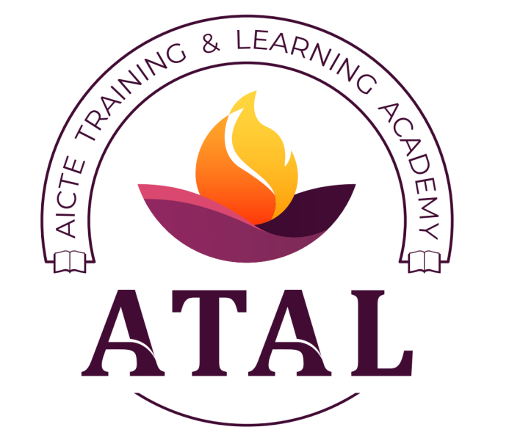

**A Five Day ATAL Online**

**Faculty Development Programme**

**On**

**CYBER SECURITY**

**8th – 12th February 2021**

**In Association with AICTE Training & Learning (ATAL) Academy**

Organized

By

**Department of**

**Computer Science & Engineering**

**NARASARAOPETA ENGINEERING COLLEGE**

**(AUTONOMOUS)**

**Thrice Accredited By NBA and Accredited By NAAC**

(Approved By AICTE, New Delhi, Affiliated To JNTUK, Kakinada)

Kotappakonda Road, Yallamanda Village, NARASARAOPET, GUNTUR DIST, A.P.

[www.nrtec.in](http://www.nrtec.in), Email: [csehod@nrtec.in](mailto:csehod@nrtec.in)

Ph: 08647 239905

Fax: 08647 239902

­­­­

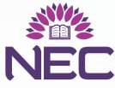

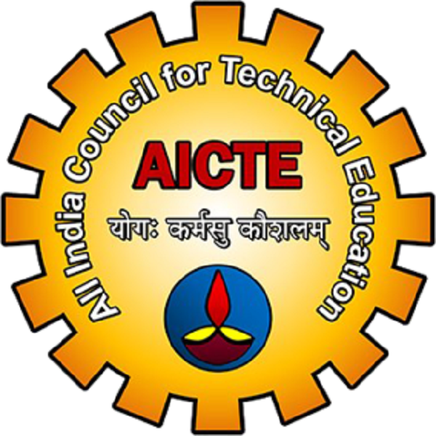

**ABOUT THE COLLEGE**

The Narasaraopeta Engineering College was established in the year 1998 by Gayatri Educational Development Society, Narasaraopet, under the leadership of Sri M.V.Koteswara Rao, who has a vision of developing this college as an autonomous institution of higher learning & knowledge in the heart of Palnadu Region. The college is approved by AICTE, permanently affiliated to JNTUK Kakinada, Accredited ‘A’ Grade by NAAC and Accredited thrice by NBA. The college has three recognized R&D centers by JNTUK. NEC is conferred as ‘AUTONOMOUS’ in the year 2016. The college has launched Incubation Centre where the students can implement their ideas. The college has an MOU with ByteXL to set up a Centre of Excellence(COE) within the campus to train students in the field of Cyber Security. The college has an MOU with Oracle University (USA). NEC has MOUs with various Foreign Universities. The college offers seven M.Tech programmes, two PG courses of MCA, MBA and Seven courses at B.Tech level in the branches EEE, CSE, IT, CSE (AI), ECE, ME and CIVIL. The college has well equipped laboratories including 1000 computers with a bandwidth of 146 MBPS internet. Microsoft Innovation Centre was established in the college through which more than 200 Mobile Apps, 50 Cloud Apps and 100 Windows Apps are uploaded every year.

In order to build a vibrant entrepreneurship ecosystem established Venture Development Centre (VDC) in association with i2E North Eastern University, USA and APSSDC. Also, the college has Indo-European skilling Centre for Mechatronics and Industrial Robotics in collaboration with APSSDC and ARC (Applied Robot Control), Germany. AP CM’s Skill Excellence Center to provide students access to the most advanced courses by industry giants. The college has established Institution Innovation Council(IIC) as per the norms of Innovation Cell, Ministry of HRD, Govt. of India with ranked 3.5 Star Rating.

**Chief Patron**

**Sri M.S.Chakravarthi**

B.Tech, MS (US),e-MBA (ISB-Hyd)

Vice-Chairman, NEC Group.

**Patrons**

**Sri M.V.Koteswara Rao** B.Sc,

Chairman, NEC Group.

**Sri M. Ramesh Babu**

Secretary, NEC Group.

**Co-Patron**

**Dr. M. Sreenivasa Kumar**

M.Tech., Ph.D (UK)., MISTE.,FIE (I).

Principal.

**Convener**

**Dr. S.N. Tirumala Rao**

Professor & Head, Dept. of CSE.

**Coordinator**

**Dr. B. Jhansi Vazram,**

Professor in CSE

**Co-Coordinators**

**Dr. S. V. N. Srinivasu,**

Professor.

**Dr. G. Syam Prasad,**

Professor

**Dr. T.V Sai Krishna,**

Professor

**Dr. K.Lakshminadh,**

Professor

**Dr. S. Siva Nageswara Rao**,

Associate Professor.

**Dr. M. Venkata Reddy**

Associate Professor

**ORGANIZING COMMITTEE**

**Ms. G. L. N. Jayaprada Mr. K.N. Rao**

**Ms. M. Sireesha Mr. K. Gnanendra**

**Mr. P.Lakshminarayana Ms. O Aruna Mr G.Lakshminarayana Ms. Ch.Kamala Mr K.Satyam Reddy Mr Sk.K.M.Basha**

**Mr K.V.Narasimha Reddy Mr Y.Suresh**

**Ms. S.Chaitanya Bharathi**

**Objective of ATAL FDP**

Cyber Security awareness is one of the most important aspects that everyone must handle in their day to day operations. This online FDP will discuss and demonstrate how technology becomes vulnerable to cybercrime and how hackers exploit technological systems. Hands-on sessions will explore the depth of knowledge in Cyber Security.

This Programme provides an opportunity to perform research in the area of Cyber Security. The Programme also tends to provide a forum for academic experts, industry experts and research scholars to exchange and share their experiences and innovations about all aspects of Cyber Security

**Registration:**

 The faculty members of the AICTE Approved institutions, PG & Research scholars from Government, Industry can participate in this FDP.

 Number of participants is limited to 200

 To register, please visit :

<https://atalacademy.aicte-india.org/signup>

 There is No Registration Fee.

 Participants will be selected on first-come first-served basis

 Selected candidates will be intimated by e-mail.

**Guidelines:.**

❖ A test shall be conducted by organizing committee at the end of the programme.

❖ E-certificate shall be issued to those participants who have attended the program with minimum 80% attendance and scored minimum 60% marks in the test**:**

❖ Last date for Registration: 05/02/2021.

❖ Intimation to Participants: 06/02/2021.

**ABOUT THE DEPARTMENT**

The Department of CSE started in the year 1998 with an intake of 60 later it started M.Tech in PG Level with an intake of 18. Now the intake of the CSE is 240 in UG and M.Tech is 36 in PG, the department has thrice accredited by NBA, right from the inception of the college, boasts of well experienced and technically excellent faculty members. The department imparts knowledge and skills to inculcate the professional responsibilities, leadership qualities to succeed in diverse career, capability to utilize engineering skills in industry. The sincere efforts and dedication of our faculty and keen interest exhibited by our students have produced not only a commendable academic record and also remarkable achievements in co-curricular and extracurricular activities. The laboratory infrastructure is excellent with state of the art equipment and software. The department faculty encourages the students to implement innovative ideas in their project works, to develop industry readiness and R&D. The faculty has published around 40 research publication papers in different thrust areas like AR&VR,AI, ML, DL, cyber securities etc in every year. Nine Ph.Ds. are awarded under our department faculty supervision and 10 more research scholars are doing Ph.Ds. Many of the faculty members are upgrading their skills by attending the FDP, Conferences, seminars and workshops in innovative and thrust area technologies regularly. The department having 56 faculty members with 12 Professor, 18 Associate Professor and 26 Assist professors. The dept. has organized Faculty Development Programmes sponsored by AICTE,DST, MNIT JAIPUR, NITTTR, Kolkata and Chandigarh in every year