AWS workshop
Department of Master of Computer Applications, Narasaraopeta Engineering College(Autonomous) organized a one week workshop on “AMAZON WEB SERVICES” for III MCA students in association with APSSDC from 18TH to 23rd Jan 2021.
31 Students have registered for this 36-hour AWS workshop session where they were engaged on topics like virtual creation of server and deployment of application in cloud.
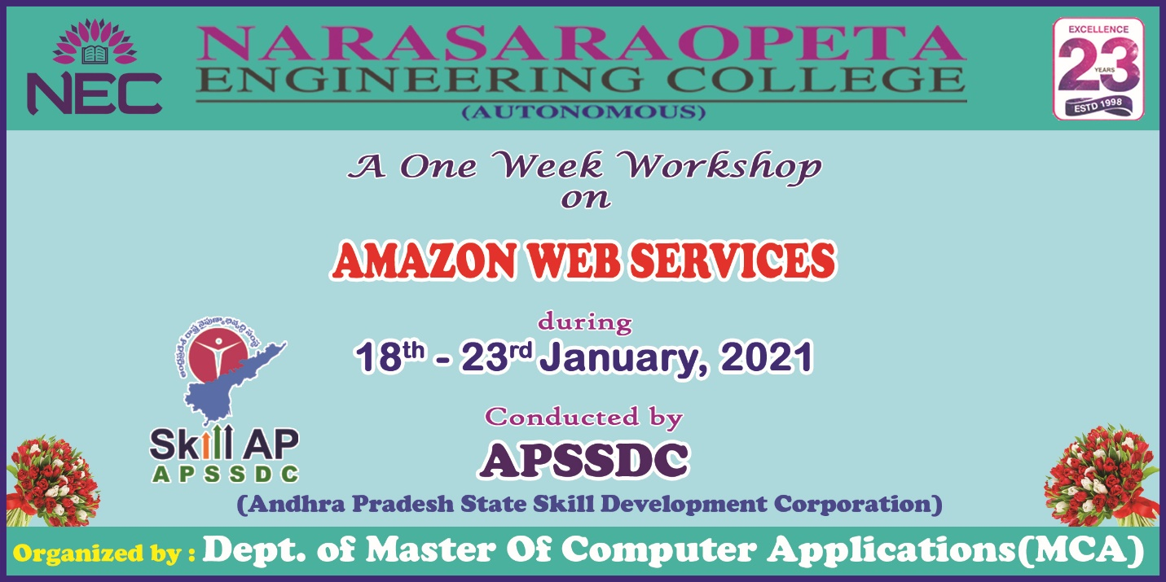

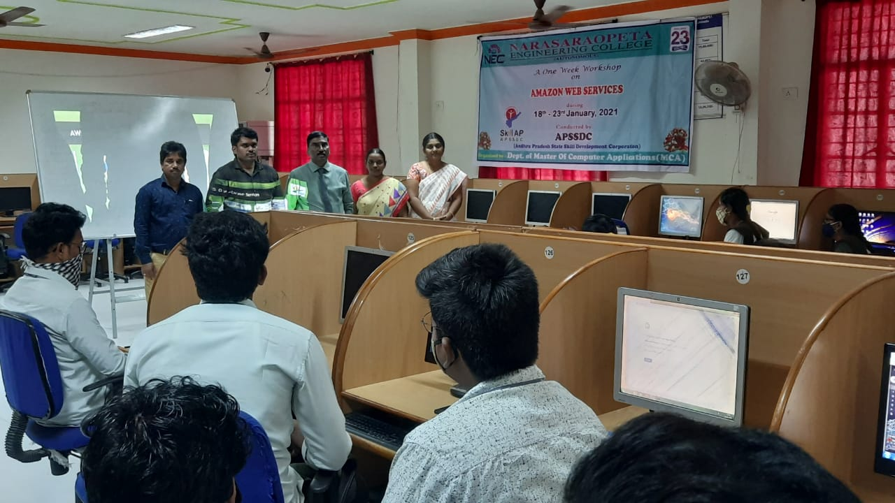
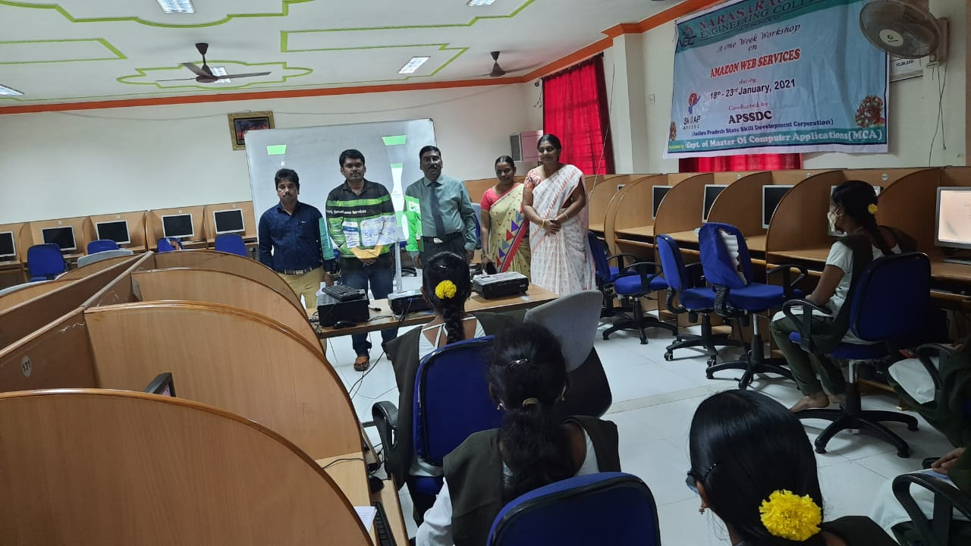

Open Source Technology
Department of Master of Computer Applications, Narasaraopeta Engineering College(Autonomous) is organized “A Five day Short Term Course on “Open Source Technologies” in association with NITTTR Chandigarh From 10/2/2020 to 14/2/2020.
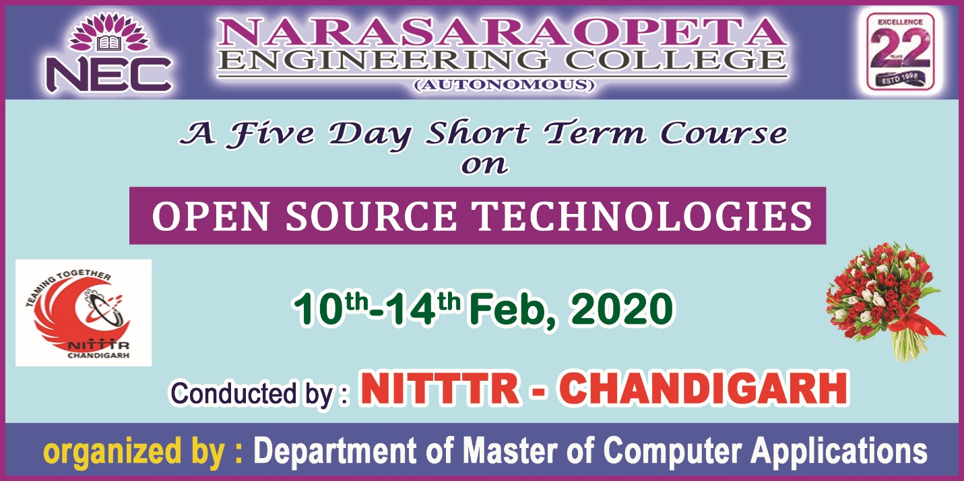

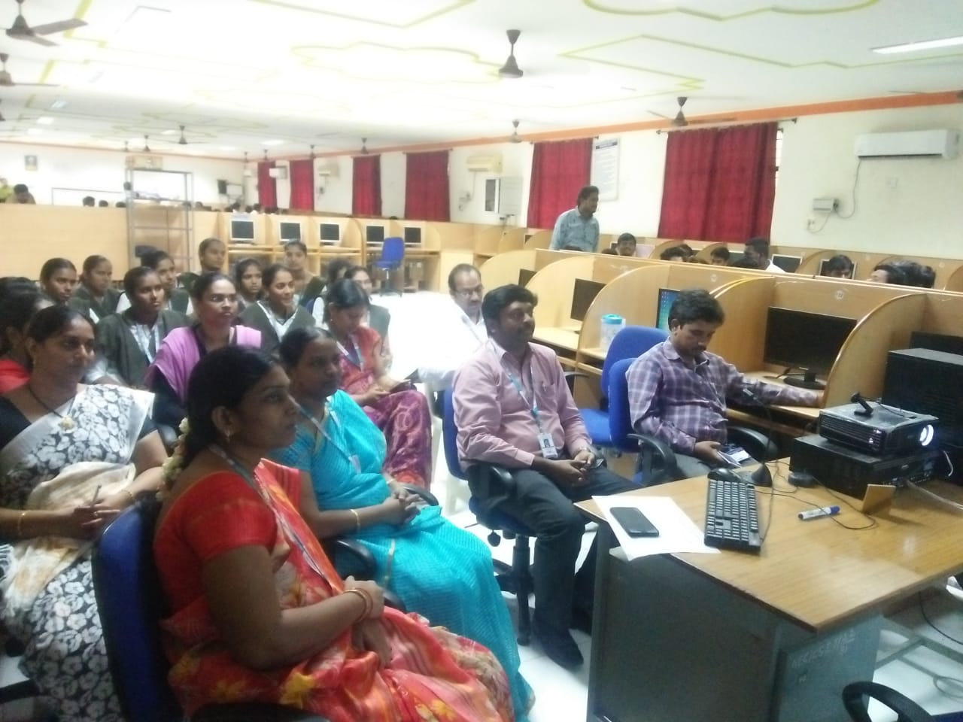
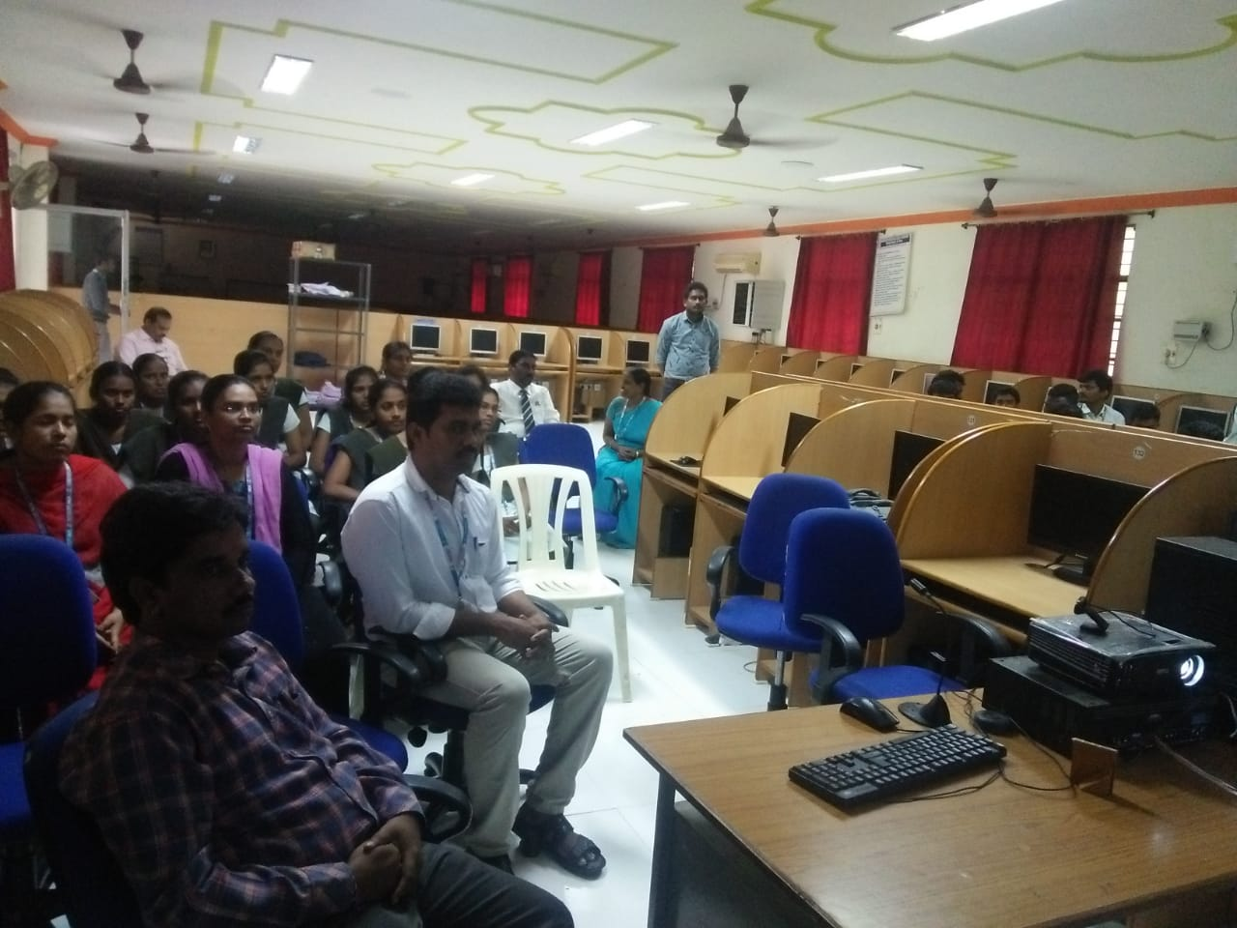

A Guest lecture on “Angular 2 Frameworks”:
A Guest lecture on “Angular 2 Frameworks” organized by Department of MCA for III MCA Students
Resource Person Name: R.Babu Naik, Sr.S/WDeveloper, BruTech. S/WSolutions, Hyderabad.

