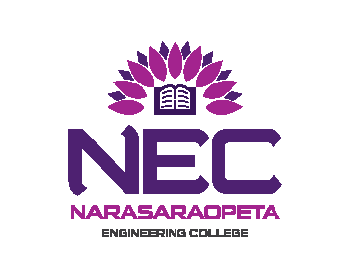
NARASARAOPETA ENGINEERING COLLEGE (AUTONOMOUS) : NARASARAOPET
EXAMINATION SECTION

MBA III SEM END EXAMINATIONS

NOTIFICATION

Notifications No. NEC(A)/CE/MBA/III SEM/REGULAR/2017/10/08

MBA III SEMESTER REGULAR EXAMINATIONS
R16 REGULATIONS (FOR 2016 ADMITTED BATCH)
NOV/DEC - 2017

CANDIDATES APPEARING FOR THE ABOVE EXAMINATIONS COMMENCING
FROM 20-11-2017 ARE INFORMED THAT THE APPLICATIONS WILL BE RECEIVED AS PER THE TIME SCHEDULE GIVEN BELOW:

Fee for whole Examinations : Rs.1200/-

EXAM REGISTRATIONS | LAST DATE
Without Late Fee | 23-10-2017
With Late Fee of Rs.100/- | 28-10-2017
With Late Fee of Rs.1000/- | 04-11-2017

*Applications are also admissible up-to one day before the examination
with a fine of Rs.5000/-

Detailed Time Table for theory Examinations will be notified in the Departmental Notice Boards.

Note to the Candidate: Applications can be obtained at the college examination section and duly filled in applications should be handed over in the college examination section with necessary fee.

Mere payment of examination fee does not guarantee eligibility for appearing for examination, it is subject to fulfilment of academic requirements and other requirements specified time to time by the college authorities.

Date: 17-10-2017 Chief Controller of Examinations.

